

BUDGET COMMITTEE

MINUTES
Tuesday, April 8, 2010

- Call to Order by Chairman Tracey McCormick at 7:000 pm.
- Committee welcomed new members Chip and Bob.
- Election of Officers Recommendations and votes
Chair-1st Proctor 2nd by Chip for Tracey Votes- Yes- Unanimous No- 0

Vice Chair- 1st Tracey 2nd by Chip for Jean Vote - Yes- Unanimous No- 0

Secretary- 1st Tracey 2nd by Chip for Proctor Vote- Yes- Unanimous No- 0
Given Proctor does not have a computer Tracey will help set up how to take minutes and others can help type it up.

- Visitors Comments- None noted.
- Appointment of Department/Committee Liaisons See attachment for list
All committee members have been assigned to at least one department. Attending meetings to which you are a liaison or other forms of communication with a person on that committee is essential.

- Set Regular Meeting Dates Second Thursdays of Month at 7pm
May- 13th June- 10th July- 8th Aug- 12th September- 9th Oct- 14th Nov- 11th Dec- 9th Jan- 12th Feb- 10th

Meeting dates added for Summer time to include education on budget items. All meeting dates Nov – Feb are tentative dates. Members will need to attend other meetings as well during the budget season. They will be notified as dates become available.

- Approval of Minutes for January 14 and February 5th 2010.
Only two old committee members were present to discuss and vote. Proctor also requires a copy of the minutes to review prior to next meeting.

- Agenda items for next meeting- Review of training materials, Committee members update, up coming topics to be aware of- contracts, wage and salary, etc and review of the minutes form 1/14/10 and 2/5/10.

- Schedule Next Meeting will be May 13th 2010 at 7pm in the Selectman’s office

- Visitors Comments- None

- Adjournment: On a motion from Chip, seconded by Proctor, the meeting was adjourned at 7:20 pm.

For the Committee
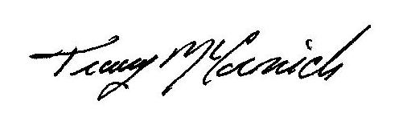
Chariman

